Project Development Phase
Model Performance Test

Date | 27 June 2025
Team ID | LTVIP2025TMID59839
Project Name | Pattern Sense: Classifying Fabric Patterns using Deep Learning
Maximum Marks | 10 Marks

Model Performance Testing:
S.No. | Parameter | Values | Screenshot
 | Metrics | Classification Model:  Confusion Matrix -, Accuracy Score- & Classification Report - | Confusion Matrix  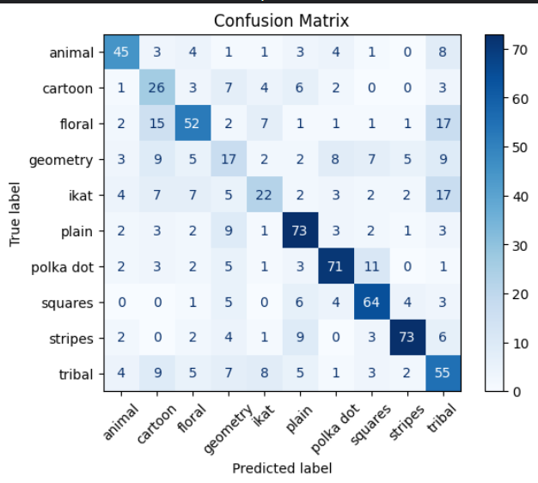  Classification Report  